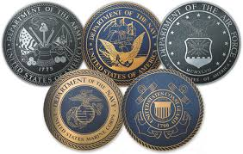
Military Necessity Community Service Project
Please join MMHS Leadership and the Patriot Club in a community service project by gathering personal necessity items such as shampoo, body wash, toothbrushes, toothpaste, sunscreen, etc. These items will be handed out to the men returning from service on
USS Asheville on October 2, 2013.

Each item is worth 1 point and the TEACHER with the most items will win Rootbeer Floats for ALL of the students (period 1-7)
All items are due no later than
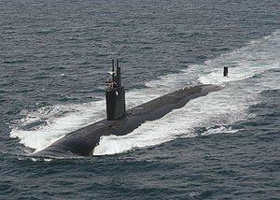
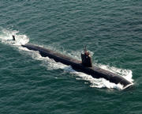
Wednesday, September 25, 2013
Any items that are not delivered on October 2nd
will be donated to the USO.

